USE CASED DIAGRAM

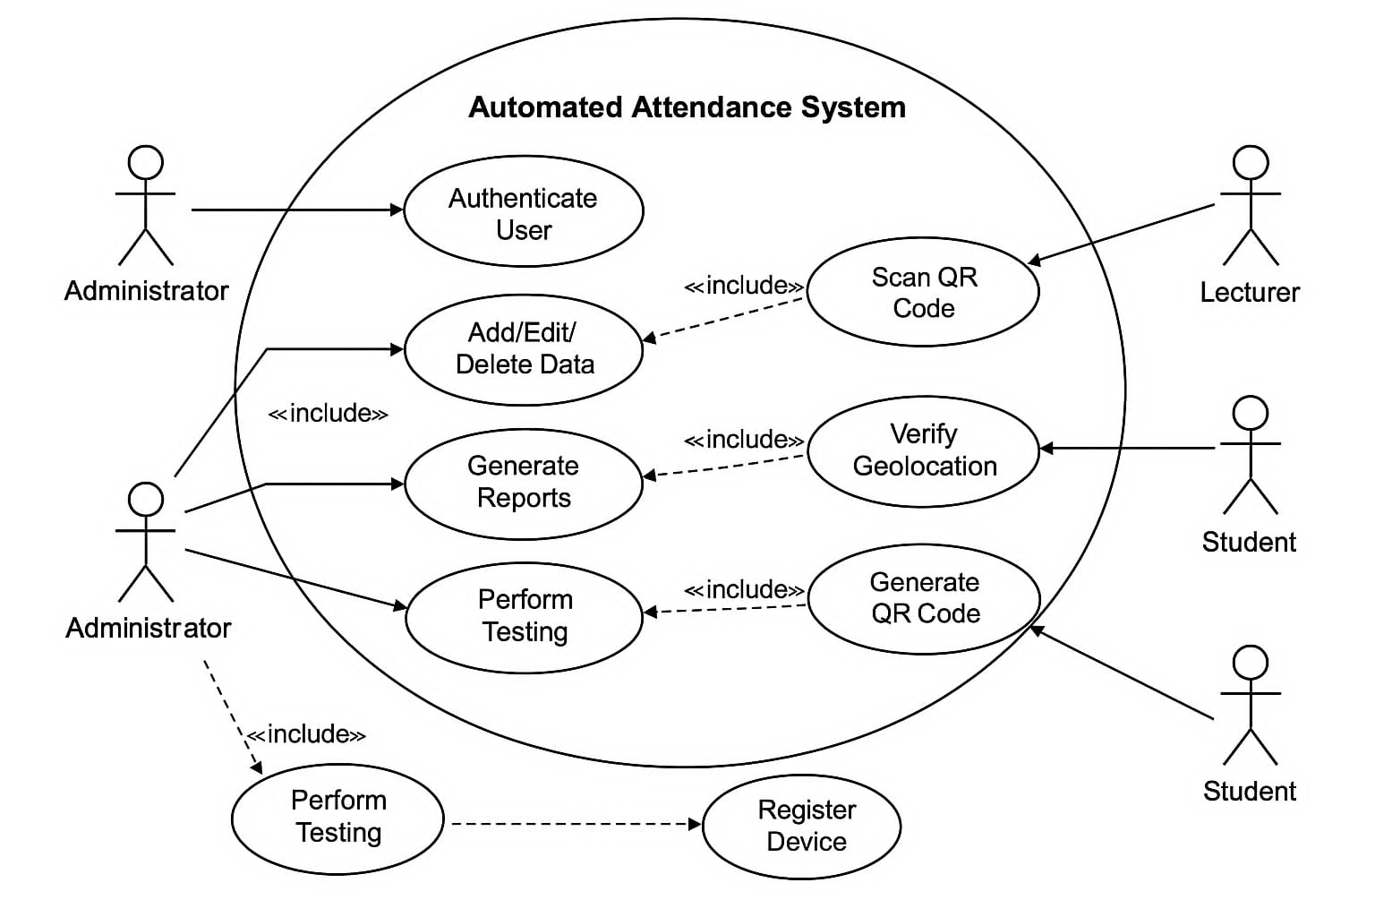

Their Roles

1. Administrator  
Authenticate User: Logs in with secure credentials to manage the system.  
Add/Edit/Delete Data: Manages users, courses, attendance records, and devices.  
Generate Reports: Generates reports of student attendance, trends, and faculty assignments.  
Perform Testing: Conducts User Acceptance Testing, System Testing, and Unit Testing to ensure software quality.  
  
2. Lecturer  
Scan QR Code: Scans students' QR codes to register attendance.  
Generate QR Code: Creates session-specific QR codes to be scanned by students.  
Register Device (via include relationship): Registers trusted devices before being used for attendance tracking.  
  
3. Student  
Scan QR Code: Scans the QR code displayed by the lecturer to mark attendance.  
Verify Geolocation: The system validates the student’s location to prevent proxy attendance.